Michaela Gormanova

Update of existing assets on The Layer
[Document subtitle]
Contents
Update of existing service assets on The Layer 3
Initial cleansing of data and update of data with the key information 3
Who should be responsible for the data cleansing? 3
Which Template can we use for ‘upsert’? 3
IMPORTANT - Freeze Asset Changes! 3
What to look for while working on data cleansing 4
Breakdown of the data updates 6
1. Product Name (Service Name) 6
2. Service ID (MSISDN) – Key field for reconciliation report 6
3. Live – Mandatory field 7
4. Connection Date 8
5. Core – Key field for reconciliation report 8
6. Expiry Date 12
7. Cease date 13
8. Recurring Cost 13
9. Eligible 13
10. Term 14
11. Fixed Dial – Mandatory Field 14
12. OGR (Ongoing Revenue) – Key Field for Reconciliation report 14
13. Asset Owner – Optional field 15
14. Roaming – Mandatory Field 16
15. SKU (Stock Keeping Unit) – Optional field 16
16. Unique ID – mandatory field for upsert 16
17. Meta Fields – no changes required 17
18. Category – no changes required 17
19. Base Category – Mandatory Field 17
20. Customer Name – Mandatory Field, do not change. 17
21. Supplier – Key field for reconciliation report 17
22. Intermediary 19
23. Parent Service Unique ID 22
24. Site 22
25. Cost Centre 23
26. User name 23
27. Account Number 23
Vodafone One Net assets – complete users! 24
Mandatory fields for Import and Upsert 25
1. Base Category 25
2. Customer Name 25
3. Fixed Dial 25
4. Live 25
5. Roaming 25
6. Unique ID – Required for upsert only 25
Vodafone Reconciliation report - Key required fields 25
1. Service ID (MSISDN) 25
2. Core 26
3. OGR % 26
4. Supplier 26
Maintenance of the data after Import/Upsert 27
Agree an asset management process internally 27
Permissions 27
Manual Editing of Assets 28
Assets update via Batch Editor 29

Update of existing service assets on The Layer

Initial cleansing of data and update of data with the key information

Who should be responsible for the data cleansing?
The person responsible for updating the service assets should:
- Understand the impact of asset changes to the system
- Have a good knowledge of the customer base and access to other supplier portals which might be needed to clarify the accuracy of the existing data.
- Have good attention to detail.
- Have basic skills with excel.

Which Template can we use for ‘upsert’?
The only template suitable for the service asset upsert is the pre-populated spreadsheet from Data Manager. Please request this from your Account Manager if you do not have access to Data Manager.
Only this template will work for the upsert as it contains a unique service asset ID which is used to update the asset details.
N.B.: Do not use All Service Assets report
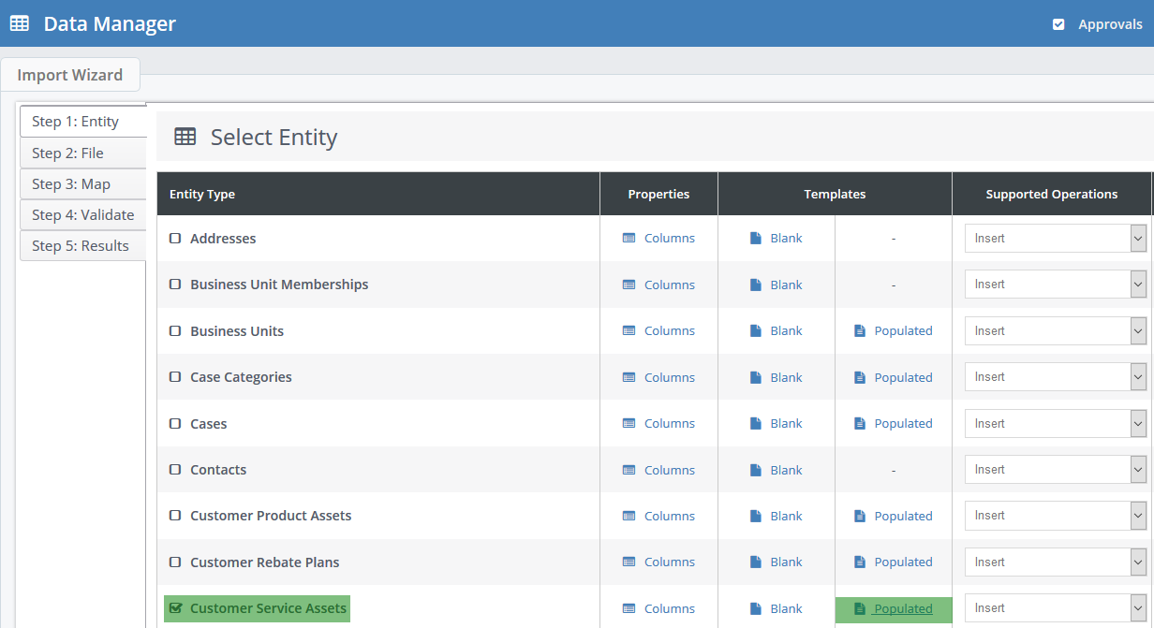

IMPORTANT - Freeze Asset Changes!
Once you export the assets from the system, request that nobody makes any changes to assets. This will be the same for manual changes to the assets or conversion of assets via sales orders. The risk is that renewal assets will be updated from a new sales order however your spreadsheet will have the old data. During the upsert your old data will override the new data from the sales order.

What to look for while working on data cleansing
Start methodically from the first column of the services to the end.
Don’t be tempted to skip through to the fields you want to work on. Sometimes there is a need to look at a combination of columns at the same time, but always come back to the column you started with.
Tips:
- Use filter option to work with data instead of scrolling through the whole spreadsheet. Using the filter will shorten the number of entries that you need to check.

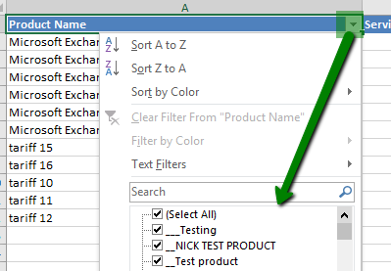

Try searching for specific words that you know shouldn’t be present in the fields. E.g. test, user names in product names.
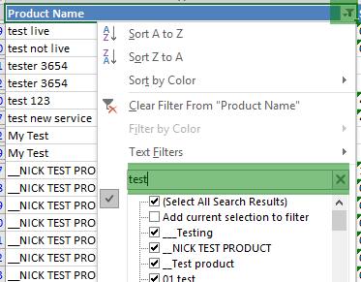

Blank fields
Ensure that each field has a valid entry. This will work as a sense check to ensure that you have completed all fields. E.g. for blank recurring costs add zero if applicable, don’t leave it blank. The only exceptions are Cost Centre, User Name, Site, SAN Supplier Account Number, adding zero to these fields will create zero accounts for these entities.

Breakdown of the data updates

Product Name (Service Name)
What to look for in the product name field
  - Blank fields – make sure that every product has a name. Filter by blank fields and add the relevant tariff name. If you would like to remove the assets, this would need to be done manually in the customer record.
  - Text Search – search for a keyword like ‘test’ and decide whether you would like to remove the tariffs or keep them on the system.
  - Text Size - service name – spot check the service name for extra long or short text.
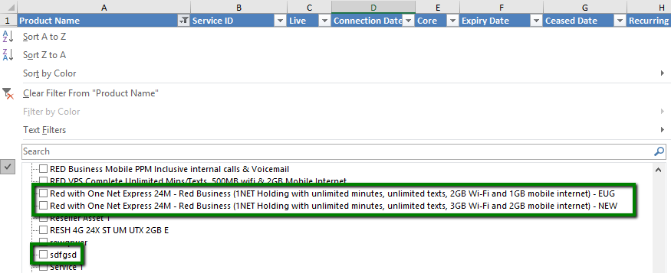
  - Visual check – a quick scroll through the product names via search will help you spot anything unusual and take required action.

Service ID (MSISDN) – Key field for reconciliation report
What to look for
  - Blank Field – all assets should have data, even if it’s a landline number or license name.
  - Text Field – arrange the column in alphabetical order to check if the text in the column is valid and doesn’t require changes. See example of bad data below:
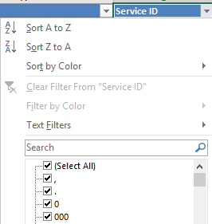
  - Length of the phone number – Use the formula which will count the qty of digits in the field:
=LEN(B2)
Add a new column and enter =LEN(click on the service ID field as per the example below B2 or just type B2 into the formula)
Then apply the formula to the whole column.
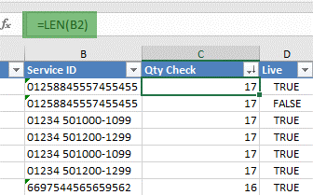
Filter the numbers which don’t fit the standard and check what the correct number should be.
N.B.: Don’t forget to remove the column with formula once you have fixed the Service ID numbers.

3. Live – Mandatory field
This is a mandator field, as you are using a template exported from The Layer this shouldn’t have blank fields. However, if you are adding new assets make sure you populate the field as TRUE or FALSE.
What to look for
  - Blank – check for any blank fields and update accordingly. Note: if you leave the field blank it will default to FALSE.
  - Live Base – are you able to check the qty of assets against the supplier portals? Filter on the live column to view only TRUE assets and check qty of assets to give you the qty of your live assets
Sense check, filter by:
    - All TRUE assets in column ‘Live’
    - The expiry dates set in the past
    - Exclude Ceased dates
This check should provide you with a list of assets which are due to be renewed, on rolling contracts, or, perhaps, have ceased with the supplier already. Therefore, the live status might need to be updated to False or it may be that the assets should be targeted by sales for renewal.
  - False – If a user manually adds an asset, it’s possible that the asset wasn’t marked as live by mistake.
Therefore, a good sense-check is to filter by:
    - all FALSE assets in live column then
    - the expiry dates set in the future
    - Exclude ceased dates
If you end up with some data on the list, check if the assets are correctly marked as non-live or if these were ceased.
Outcome:
    - Mark as live - if the assets are incorrectly marked as non-live.
    - Add ceased date – if the asset has been ceased before the expiry date and follow your internal process for ceasing assets.

Connection Date
What to look for
  - Blank – is there a reason why the connection date is missing? If you are able to work out the approximate connection dates from expiry and term update the connection date. If possible, use a supplier portal to check for accurate connection dates.
  - Extremes – a connection date with the extreme future date e.g. 2050.
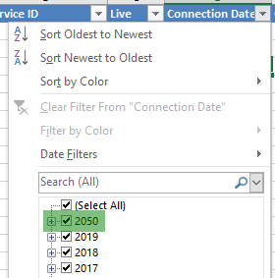

Core – Key field for reconciliation report

What is a core field?
Core Tariff– the term core tariff in The Layer refers to a ‘targetable’ service and originates in the price books. To simplify the term, core is any connection which requires a unique mobile number, fixed line number or GTN. Some people might refer to a core service as the primary service, to which all non-core (or dependent services) are linked. This is recommended practice, however, it is possible to set the status of a primary service as non-core, if required for any reason.
Core Asset – on The Layer we have introduced an amendable field to match the same logic as the core field in the price book. This was introduced end of year 2018, therefore any assets processed before that time do not have a core status.
Note: The core field in assets will be auto-populated from the price book on the conversion from sales orders to assets.

Non-Core tariffs and assets
Non-core tariffs are dependent services as mentioned above i.e. they can’t exist on their own. For example, ‘bolt-ons’ and additional services which are dependent on an existing primary tariff.

Visibility and Use of Core field
The core fields are visible in many different places and follow the process from a quotation to sales order and finally to assets.
Price book
Core field statuse is selected in price books (inventory). It can be updated manually per service or via the price book upload. See your sales manager if you require any changes to core fields in the price book.
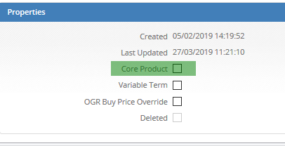
Quotation
Core status is visible in the quotation builder for easy identification when creating a quotation.
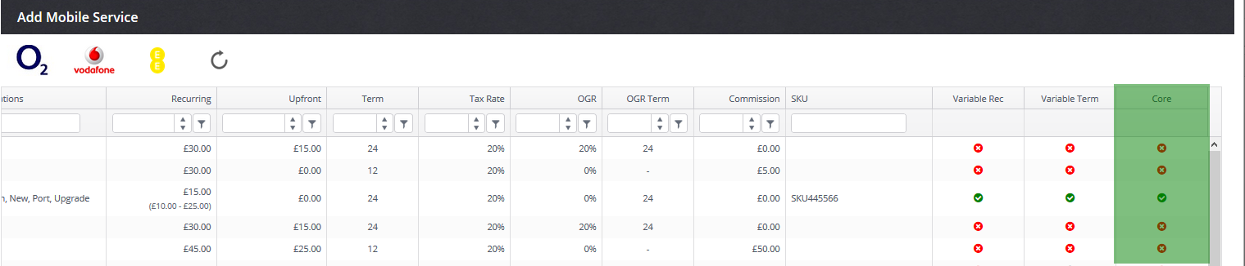

Sales orders
In Sales order data capture the core fields are visible, however non-amendable as the changes should be pushed from the price book
.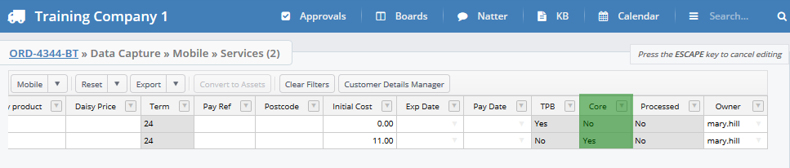

Assets
When manually creating an asset, you can specify whether the service is core or non-core through edit screen
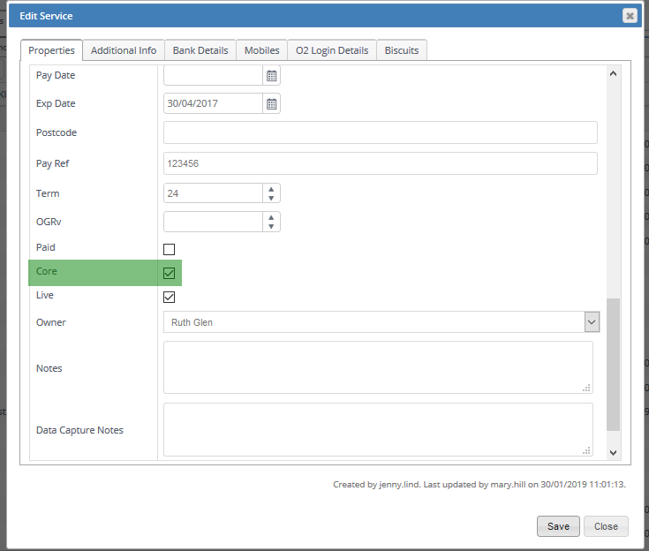

It’s also to update the status via the batch editor.
Batch Editor
If you want to update multiple services in bulk, the batch editor option is the quickest way to do so (unless you’re using Data Manager to update multiple statuses). Simply enable the first service and drag the field down as you would do when updating a spreadsheet.
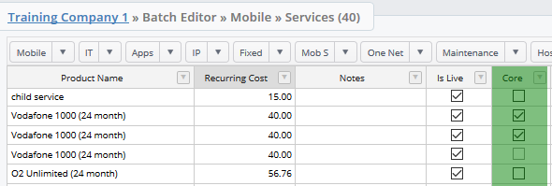

Sales Order Leaderboard
Within the Sales Order Leaderboard you will be able to tell how many core services were connected, see example below.
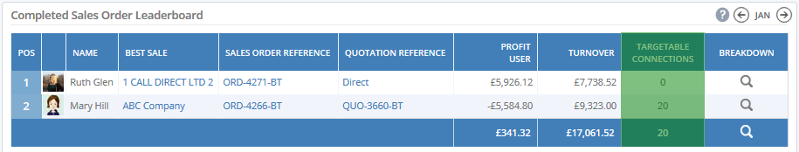
Service Connections by Supplier & Classification
To provide Sales Managers with a monthly breakdown of core services per supplier and classification you can use this widget. The values are based on core services.
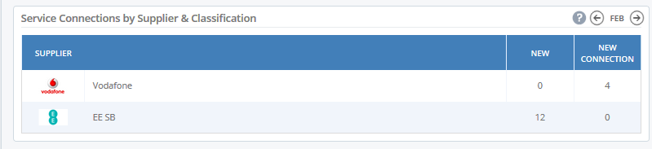

Data Manager checks
  - Blank – filter all blank fields and populate as appropriate TRUE/FALSE.
  - Check via Reconciliation report
  - If you find yourself changing the core field status of assets converted from sales orders created after Jan 2019 inform the price book manager about this as well. It’s possible that the core field is not updated correctly in the price book therefore this will continue to re-occur until the price books are correctly updated.

Expiry Date
What to look for
  - Blank - is there a reason why the expiry date is missing? If you are able to work out the approximate expiry date from connection date and term. You can use the following formula for ease of updating:
=EDATE(D3,I3)
D3= Connection date
I3= Term
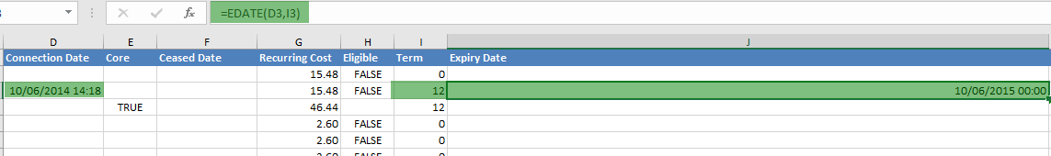
  - Extreme dates – for expiry dates far in the future, check if the dates are correct. It’s possible to either have a visual check of the data in the filter view (below) or select the date filters to filter only on expiries after a certain date.

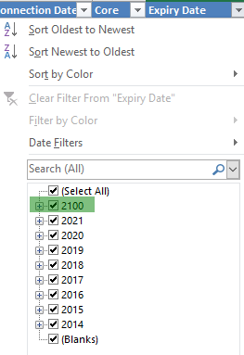

  - Past dates with no ceased date – expiry dates in the past few years which are still live and do not have a ceased date. If these assets should be marked as non-live change the column Live to False and add a cease date if you know it. Another option is to remove the assets from The Layer and the spreadsheet.

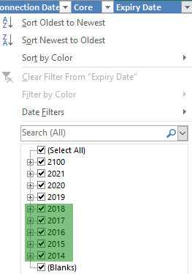

Cease date
What to look for
  - Ceased dates in the past and in live status - These assets should be marked as non-live (FALSE) as the cease date has passed already. Follow your connection cancellation process to make sure that all necessary actions have been taken and checks completed.

Recurring Cost
What to look for
  - Blank – if there are any blank fields add zero to the fields.
  - Extreme – check for very high numbers or negative numbers in the recurring cost field.
How to bulk increase the recurring price of assets i.e. RPI (Retail Price Index)/ Inflation increases
If you or your supplier increases the recurring cost of specific assets by x%, you can update the recurring figure by adding the relevant formula, and then copying the values into the recurring cost column. This will be updated on the import as well.

Eligible
This field is usually used to specify whether a tariff is included in supplier churn percentages or not. Note that this field can be used for a different purpose which will depend on your company set-up. For example, in this instance, we have renamed this field in assets to monitor whether something has been paid or not.
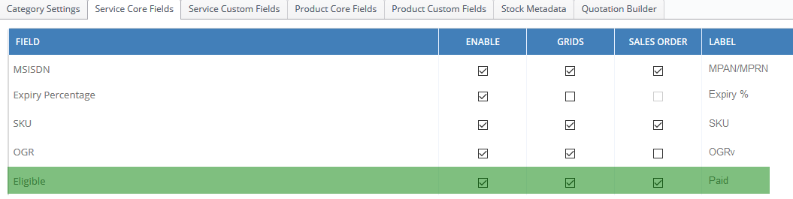
Therefore, before you amend this column speak to your internal Layer administrator to find out if and how this is being used.

Term
What to look for
  - Blank – we would recommend that the term is always populated, even if the value is zero. If the tariff is on a rolling contract you can either match the parent tariff term or keep it as a 1-month contract.
  - Extreme - check for very high numbers

Fixed Dial – Mandatory Field
This is a mandator field, as you are using a template exported from The Layer this shouldn’t have blank fields. However, if you are adding new assets make sure you populate the field as TRUE or FALSE. Similar to Eligible field this field can be used for different purposes, therefore please check with your Layer Administrator before making changes.

OGR (Ongoing Revenue) – Key Field for Reconciliation report

Ongoing revenue (OGR) profit is typically used for services which are billed by a third party and where the reseller will receive a % of the ongoing customer revenue.
The OGR field always existed in price books and sales orders, however, was also added to assets at the beginning of January 2019. This means that any assets which were converted after that time will have the OGR % auto-populated. The workflow of this field begins in your price book, therefore having this information correct in the price book is the first step. Each tariff takes the OGR % through from quotation to sales order and after conversion to assets also. The OGR % is amendable in the assets in case of future changes from your suppliers.
View of the OGR % in the quotation builder screen.
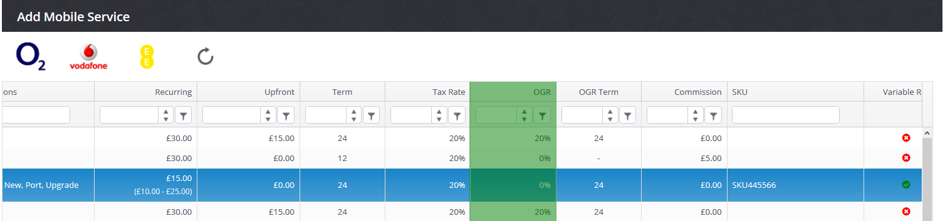
View of the OGR % in the assets grid.
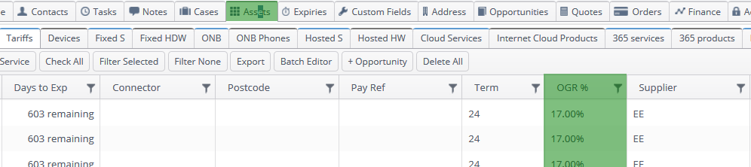
OGR % field will be important to calculate expected revenue in the reconciliation report, if this field is not populated it won’t calculate it, see example below.
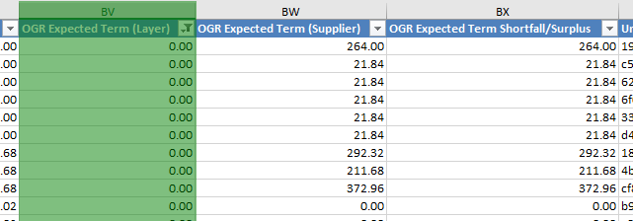
What to look for during the checks
  - Blank – all assets should have OGR filled in even if it’s populated with zero for tariffs with no OGR (wholesale model).
  - Extreme – check for very high numbers or text instead of a value.

Asset Owner – Optional field
The asset owner on The Layer can be used to manage renewals on the system. If you have different sales users who look after different base categories (i.e. hosted, mobile) you can split a customer’s services by multiple sales users set at asset level.
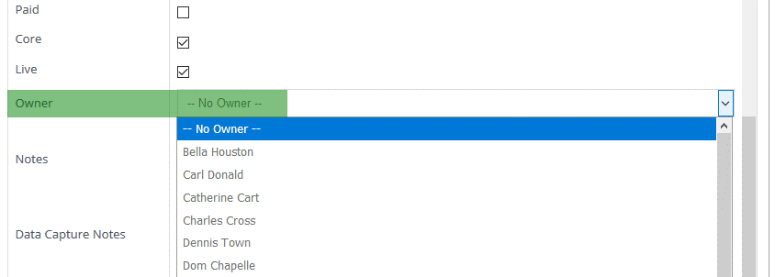

The asset owner will automatically be allocated from the quote owner (or opportunity owner depending on the option selected in settings) which automatically becomes the sales order owner. This means that the sales users can use their own renewal stacks and contact customers far in advance to renew their contract.
Sales managers can therefore use this opportunity to update all service assets with the sales users’ names which will then fall into their respective renewal stacks. Asset owners must equal the Layer username not a user’s first and last name.
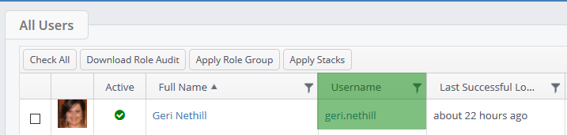

Roaming – Mandatory Field
This is a mandator field, as you are using a template exported from The Layer this shouldn’t have blank fields. However, if you are adding new assets make sure you populate the field as TRUE or FALSE. Similar to the Eligible field, this field can be used for a different purpose, therefore please check with your Layer Administrator before making changes.

SKU (Stock Keeping Unit) – Optional field
SKU can be used for products and services. This field is taken through from the price book to quotations, sales orders and then to assets. This field should therefore be matched to the price book SKU if you chose to update it.
Note, it is common practice to match the SKU to the supplier service name for ease of provisioning and reconciliation.

Unique ID – mandatory field for upsert
Unique ID is automatically populated by the system, therefore this field should never be amended or copied to another Unique ID field.
If you are adding new assets for import, leave this field blank as this will be automatically created during the import.

Meta Fields – no changes required
Meta fields were used for your original import of the data during initial set-up and were moved to custom or core fields. However, for this update you don’t need to do anything with meta fields.

Category – no changes required
The category field is taken through from the price book across to quotations, sales orders and then assets. The category is not amendable in the assets, therefore assets created manually won’t have a category allocated to them. This field doesn’t require any changes.

Base Category – Mandatory Field
Base category is a mandatory field and should be pre-populated. If you are adding new assets into the spreadsheet, please specify which base category they should belong to. The base categories differ by company, therefore please don’t use the examples below and only use your specific base categories.
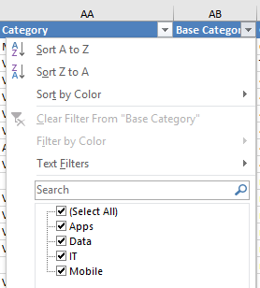

Customer Name – Mandatory Field, do not change.
Customer name can’t be amended via asset upsert as it’s based on matching the customer name and updating assets linked to that record. Therefore, if we have changed the customer name on the import spreadsheet the system would highlight that the customer record doesn’t exist on the system and wouldn’t be able to update existing assets.

Supplier – Key field for reconciliation report
Supplier field on The Layer relates to the supplier of the product or service. Every service asset must have a supplier, there should be no blank fields in the supplier column.
The reconciliation report is based on matching service assets linked to the selected supplier, therefore ensuring that the supplier details are accurate is crucial for the correct reconciliation of assets.
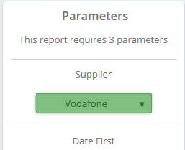

- Price book updates
- It is best practice to agree the supplier list with the person responsible for price book updates.
- Remove any duplicate supplier names
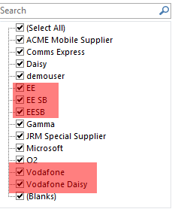

- Consider Intermediaries at the same time i.e. Vodafone services may be provided via different supplier routes including: Gamma, VPS, Daisy. In this example we would recommend keeping the primary supplier as Vodafone and differentiating the actual supplier by adding the relevant intermediary name.

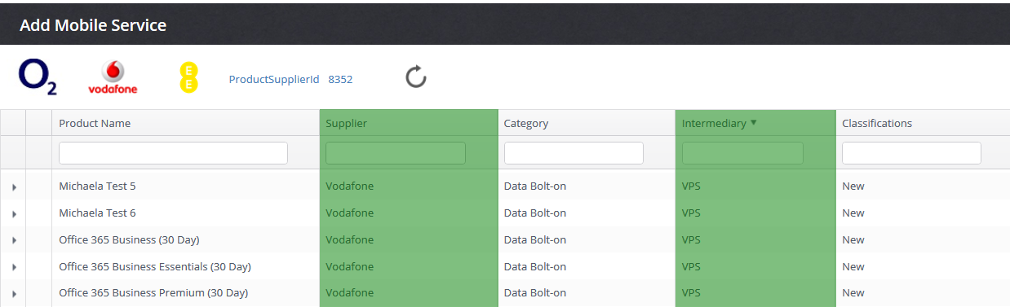

- We recommend that you update price books once you update the agreed fields. This way you will ensure that the data is consistent across the whole application. See more on Intermediaries below:

- Update the Populated spreadsheet with agreed supplier list

Once you have agreed the list of suppliers update the assets spreadsheet accordingly.
Reason for the update: The filter which will be used to run the Asset Reconciliation Report will be based on the selected supplier, therefore you want to make sure that the assets are linked to one Vodafone supplier in order to appear in the Asset Reconciliation Report.
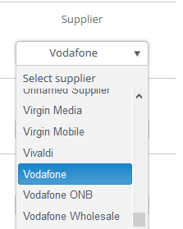

22. Intermediary
As mentioned, the intermediary field specifies the supplier route that the service will be provisioned through. As highlighted in point 21 the supplier is closely linked to an intermediary.

- Intermediary in the price books
Intermediary should consider together with suppliers when deciding the best way to populate price books. The optimum approach is to list all intermediaries (supplier routes) that you currently offer and list suppliers (networks/ infrastructure providers) that can be used from each intermediary. See an example below:
Intermediary | VPS | Gamma |  | Daisy |  | Mainline
Supplier | Vodafone | Vodafone | BT | Vodafone | O2 | EE

This will provide you with a clear list of intermediaries and linked suppliers.

- Intermediary in a Quotation
In the quotation builder sales users can chose which supplier they want to use. In the case of similar services being sold by two different supplier routes, the sales team will have the visibility of the intermediaries, see example below for more details.
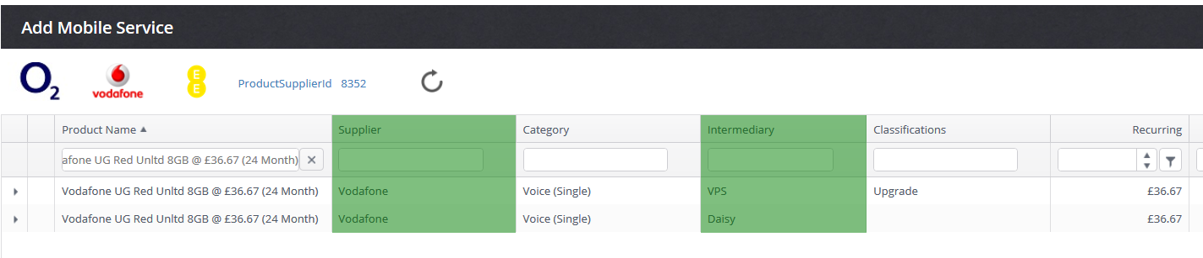

- Intermediary in a Sales order
For the processing team to know who to connect the services to they need to have visibility of the intermediary also. This is visible in each sales order in data capture to ensure it’s connected correctly.
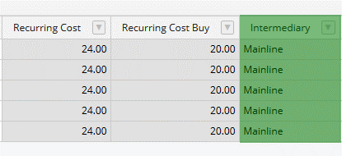
- Intermediary in Reports
The intermediary is then presented in the Sales order reports for finance and statistic purposes. All Sales order reports.

- Update Assets Spreadsheet
Once you have agreed the list of intermediaries and the price books have been updated, amend the assets spreadsheet.

  - The best way to do this is to filter on a specific supplier and match the intermediary to it. If, however you have multiple intermediaries per supplier you can use sub-category or base category to differentiate between them. E.g. One Net assets might have a different intermediary to fixed or Mobile assets. i.e. Vodafone (Supplier), VPS (Intermediary), One Net (Sub-category)
  - The Intermediary field is not mandatory therefore if you can’t be sure which intermediary the asset belongs to this can be confirmed during the reconciliation of the assets e.g. in Reconciliation report you will be able to run a report of assets which match the Vodafone partner pack and if the intermediary field is blank, that can be amended manually in assets.
Example of the report with blank intermediary field: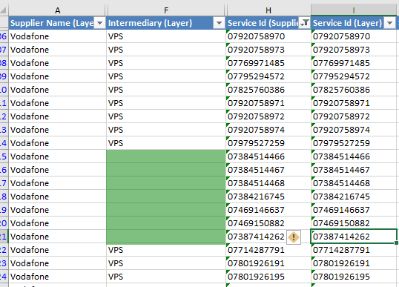

Manually edit the intermediary in assets

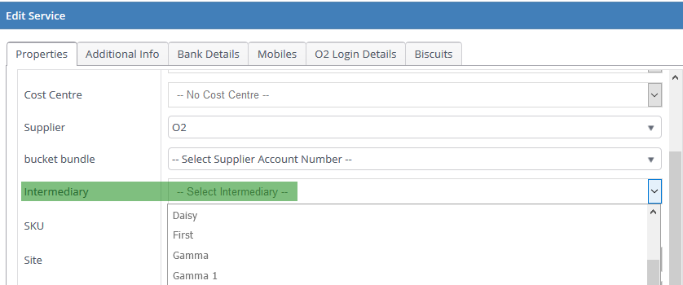

[Is it worth adding an explanation as to why you’d want to link parent and child assets? Dedicated KBA?]

23. Parent Service Unique ID
Parent service unique ID is used to link parent and child asset during the import. You might find that some of your services have this field populated already.
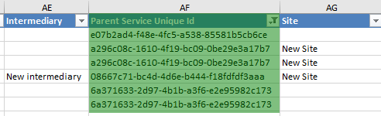
Example of the use:
Vodafone Sharer 1000 (Parent) is a parent and the mobile number is 07777777777. The asset however has two additional services.
Vodafone 5GB (Child) mobile number is still 07777777777 and
Vodafone 1000 mins (Child) mobile number is still 07777777777.
In order to link these assets during our import you will see the Parent’s unique ID number against both child assets. Parent will however not have any ‘Parent Service Unique ID number’
Scenarios:
  - Using pre-populated template – means that you don’t need to amend this field
  - Amending the link of the assets – if you want to make a change to the way the assets are currently linked you need to find the unique ID of the parent asset you want to link the child asset to and add it to column ‘Parent Service Unique ID’. This requires attention to detail and patience.
  - Adding new assets to the spreadsheet – if you are adding new assets to the spreadsheet the unique ID will not be populated until the asset has been created on The Layer therefore you won’t be able to link newly added child assets to Parent assets. This would need to be done in two stages.
    - Import new parent assets, then export the pre-populated template again.
    - Add new child assets to the spreadsheet find the Parent unique ID and add to the column for ‘upsert’.
  - Never edit the existing ‘Parent Service Unique ID’
the ID is automatically created by the system and should never be edited. Why?
    - It could lead to updating an incorrect asset on the system
    - The Layer will not be able to find the Unique ID and will therefore not be able to continue with the upsert of the rest of the data.

24. Site
See our KBA for management of Sites.
If you decide to update sites against your customer asset, simply type the site name into the column. If the site name doesn’t match the existing site list a prompt to create new site before we import the assets will be presented. See example below. 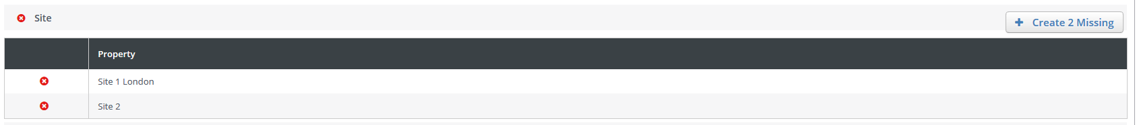

25. Cost Centre
See our KBA for cost centre management and what cost centres can be used for.
If you decide to use cost centre and update your asset spreadsheet with the data, simply type the cost centre name to the column. If the cost centre doesn’t exist on The Layer a prompt during the import will allow us to create a new cost centre. 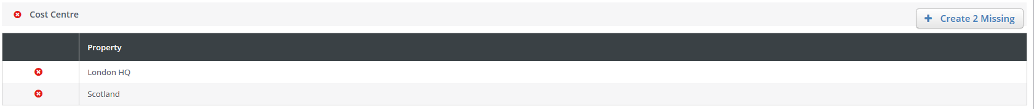

26. User name
See KBA on how to manage usernames and how to use them.
If you decide to update user name against an asset, simply type the name to the column. If the user name doesn’t exist on The Layer a prompt during the import will allow you to create a new username.
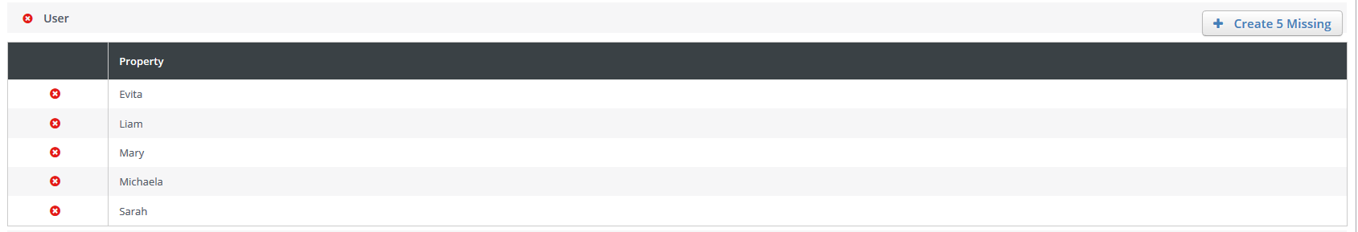

27. Account Number
See KBA on how Supplier Account Number can be used here.
If you decide to use or update Supplier Account Number (SAN) against the assets, simply type the SAN to the column. If the SAN doesn’t exist a prompt during the import will allow us to create a new one.
SAN is also important when reviewing reconciliation as this provides a further cross-check on the quantity of live assets that exist against the SAN on the reconciliation report vs the quantity in the Layer.

Vodafone One Net assets – complete users!
If you sell Vodafone One Net services (or a similar product managed in the same way i.e. two elements to the service) should be presented on The Layer in exactly the same way as the supplier pack would do. For example:
Usually a One Net Complete User is split into two different lines in the supplier payment pack
Mobile user – 077777777777
Desk user - 02086668889
Both services with separate recurring service charges, this is how your own assets should be presented on The Layer too to make sure that both numbers can be matched in the reconciliation report. The reason for that is that one asset can only have one MSISDN therefore the system will never be able to match mobile and GTN number within one asset (complete User). This would therefore lead to One Net assets being added to unmatched assets in the report.

As mentioned earlier, you can use the parent/child link to join One Net services together by making the mobile number the parent service and the desk number a child service.

UPDATE ME! Mandatory fields for Import and Upsert

Base Category

Customer Name

Fixed Dial

Live

Roaming

Unique ID – Required for upsert only
https://layersys.atlassian.net/browse/ESC-5195 - once closed amend the mandatory fields references.

Vodafone Reconciliation report - Key required fields

Service ID (MSISDN)
The reconciliation report is based on matched Service ID between The Layer and the imported Vodafone Partner Pack. This means that if your service ID is not populated or not accurate the matching process will exclude those assets from the report.
The Unmatched report from the Supplier Payment Management will help finding these assets too
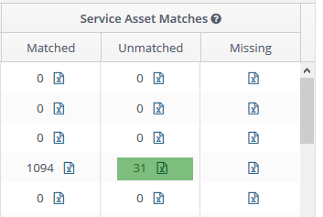

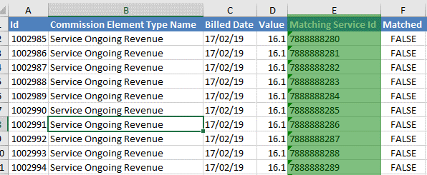

Core
See point above for how core services are used in The Layer.
The Reconciliation report looks at the core and non-core services and expected Recurring values. Typically there should only be 1 core service against an asset. If there are less or more than this number, you should investigate (by using the global search or all assets report) why there are duplicate or missing assets.
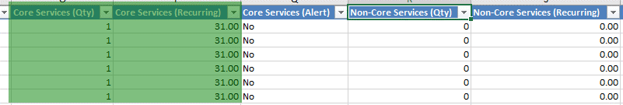
Also, if the assets are incorrectly marked as non-core the expected recurring value will be lower for the core services.
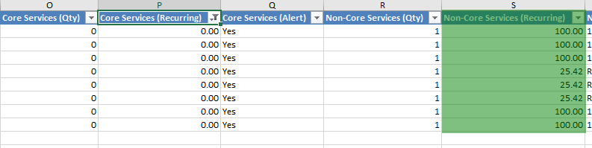

OGR %
To see the workflow of OGR % on the Layer click here.
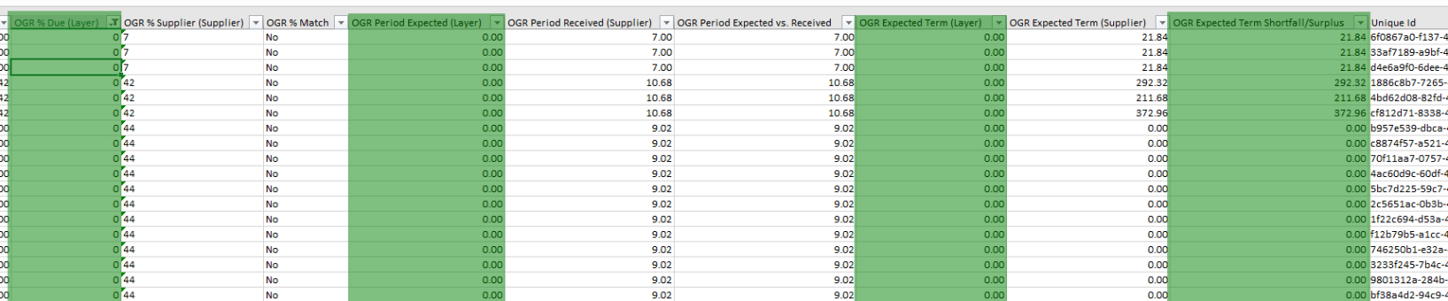
If the OGR % is not populated against the asset and is left blank this will default to zero and therefore, any further calculation for the expected revenue will be zero with incorrect shortfall

Supplier
For more information on supplier use in The Layer click here.
Supplier is a key field which needs to be 100% accurate as once again the reconciliation report will only list the assets which are linked to a selected supplier. This can result in missing assets in the report.

Maintenance of the data after Import/Upsert

Agree an asset management process internally
The first and most important step to good data management is to have an agreed process which everybody understands and can follow. Proposed questions when agreeing this process could include:
- Who can amend existing assets? – a select group of users who are reliable and users that make changes to assets on a regular basis?
- What type of manual amendments are going to be necessary? – Sim swaps, Username changes etc. agree the changes which are allowed.
- How and who will be converting sales orders into assets – this is a key role as the users with this permission will also be affecting the quality of your data. Check the type of information that can be updated from data capture on conversion (per base category)
- Ceasing of assets – this can be simply done by adding a cease date to assets, however who should be able to do this and when, is something that should also be agreed.
- Cancellation of a customer record – cancellation of a customer record doesn’t automatically cease their assets; therefore, the assets need to be ceased and marked as non-live if you want to keep asset history.
Note: This is not an exhaustive list, therefore check if there are any other scenarios that should be considered.
Contact your account manager should you require any help with the process set up on The Layer.

Permissions
Note that there are multiple permissions which will allow you to enforce your agreed process for asset management

Restriction on Assets
Self-explanatory permissions below need to be activated if you don’t want users to be able to edit and delete assets. Snapshot feature will allow you take a snapshot of current assets before making changes and load the historical data when needed.

Restrict customer asset editing
Restrict customer asset deletions
Restrict customer asset snapshots

Sales order Conversion

Sales Order Migrator - Users in this group can migrate sales order items to customer assets
Allow Restricted Amendments in Data Capture - Users in this role are allowed to edit sales order data in data capture after finalisation. Example: the ability to amend classification or expiry date in data capture.

Apply permission by Role Groups
Once you have decided on what permissions should be activated for users, create role groups which will help with applying the relevant roles to specific users. Please see our KBA for more information.

Manual Editing of Assets
After the original asset import or an update in bulk, users with required permissions will be able to edit the assets. Click on the service name and that will present you with edit service screen. Here you can update fields like MSISDN, User Name, Supplier, Recurring Line Rental, Term, Expiry Date and more.
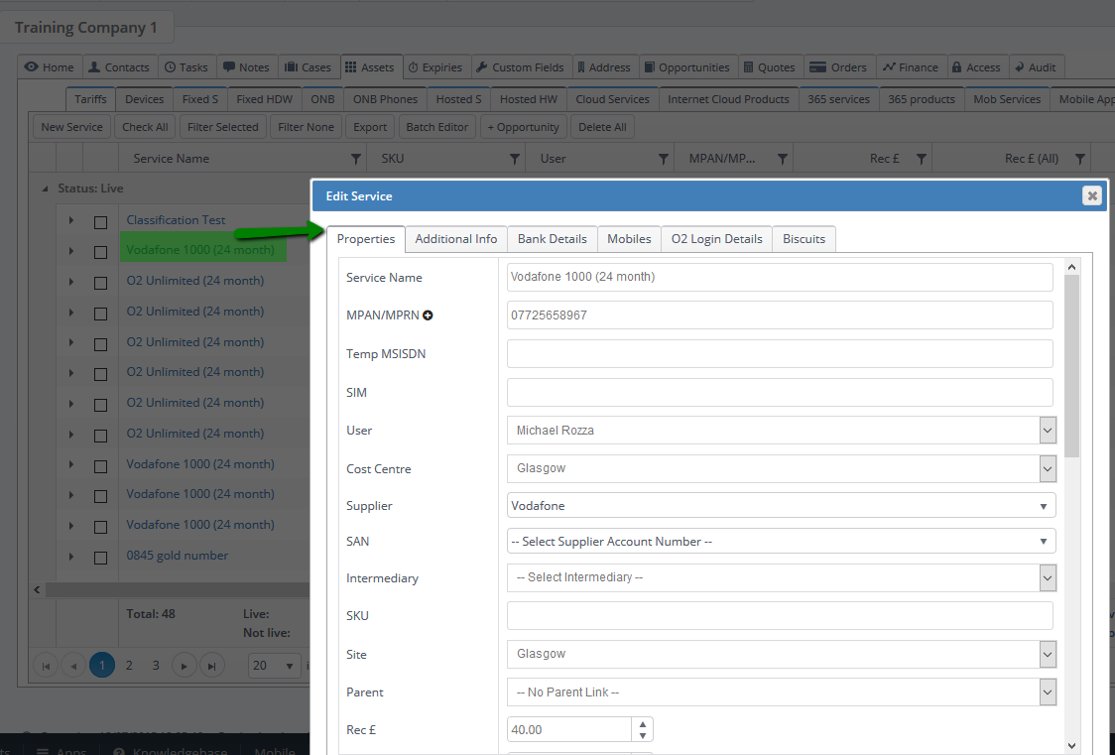

At the bottom of the edit screen you will also see when the asset was created and when it was last updated.
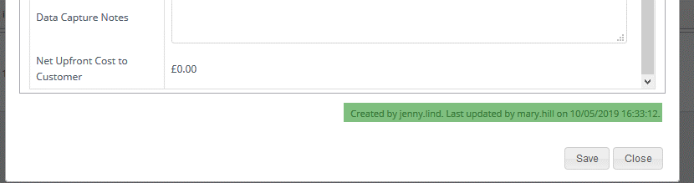

Delete individual assets via the delete button

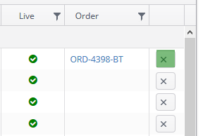

or Delete All. Note that Delete All button will remove all assets from the base category you are in.

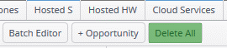

Assets update via Batch Editor
To update your customer assets quicker and in bulk, you can use the batch editor in the customer record.
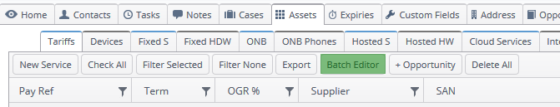
The batch editor is a similar view to a spreadsheet of all your assets against the customer record.
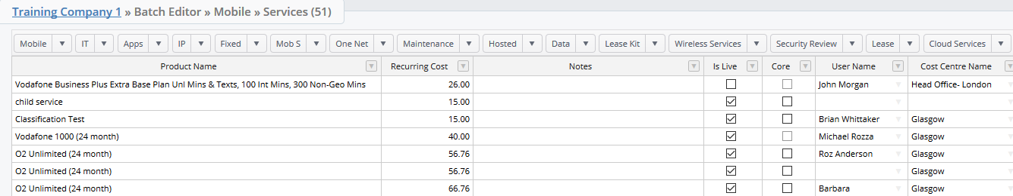
To update assets in bulk simply drag down the field that you would like to update.
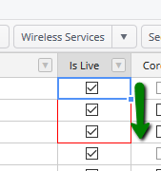
All base categories can be accessed from this view as well as services and products.
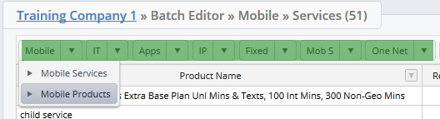
You can also export all data into spreadsheet if you prefer.
