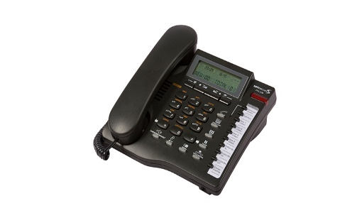****

Splicecom Maximiser

**PCS520 Handset**

Making a Call

1. Lift the handset for press the speaker button. You will hear the dial tone.
2. Using the keypad dial the number (internal or external) required.
3. The call will be made and your screen will display the details of the number you are ringing.

Receiving a Call

On receiving a call your handset will ring and your screen will display the details of the call. To answer the call lift your handset or press the speaker button.

Transfer a Call

1. Place the call on hold by pressing the Hold button.
2. Enter the number to be dialled (internal or external).
3. Wait for the call to be answered and announce the caller.
4. To transfer the call, replace your handset or press the Speaker button (if using hands free). You will no longer have control of the call.

Mute

The Mute button mutes the microphone so the other person on the call cannot hear you. A red light indicates that mute is on. Pressing the Mute button a second time returns you to normal conversation.

Call History

This is a log of the last 80 calls (received and missed) in to the telephone. Press the Calls button and scroll through using the up and down keys at the top of the phone to navigate through the call history. If the handset icon on the display is raised then the call was answered. If it is down then it was missed. To erase and entry press the clear button twice.

Redial

Press the Redial button to view the last five numbers you dialled. To call any of the numbers navigate through them using the arrow buttons and press the Dial button when the correct number is displayed on the screen.

Listen to Voicemail

If you have a new voicemail, the envelop icon will be shown on the screen of your phone. To check or listen to your messages press the Direct Access memory button, or dial *50 or 1571. Messages are then played in the order recorded. Once a message has been listened to it will be automatically deleted after 3 days unless you choose to save it.

Do Not Disturb

This facility makes your telephone busy, or diverts calls to voicemail if you have the voicemail enabled. To set – dial *291. To cancel – dial *290.

Directory

1. Press the Directory button to access the directory.
2. Scroll through the Directory using the arrow keys at the top of the phone and press the Dial key / use the alpha-numeric keys to find the entry and the press Dial.